EXPERIMENT- 7
1.
# Dataset
customer <- data.frame(
CustomerID = c(1,2,3),
Age = c(28,35,42),
Gender = c("Female","Male","Female"),
Income = c(50000,60000,75000)
)

# Bar Chart
barplot(customer$Age,
names.arg = customer$CustomerID,
col = "skyblue",
main = "Distribution of Customer Ages",
xlab = "Customer ID",
ylab = "Age")
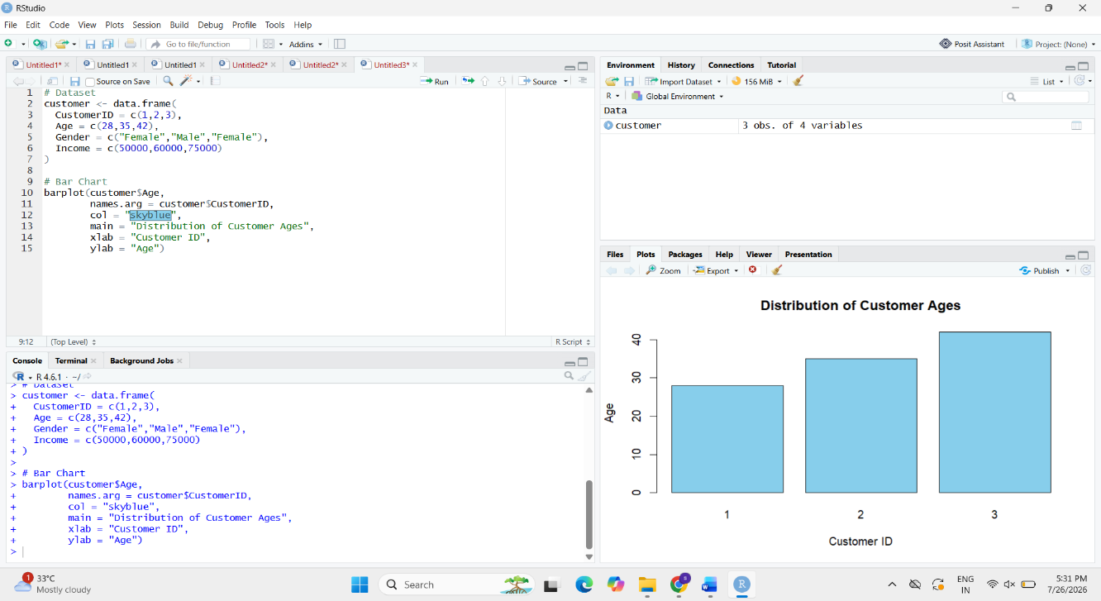

2.
# Dataset
customer <- data.frame(
CustomerID = c(1,2,3),
Age = c(28,35,42),
Gender = c("Female","Male","Female"),
Income = c(50000,60000,75000)
)

# Count genders
gender_count <- table(customer$Gender)

# Pie Chart
pie(gender_count,
col = c("pink","lightblue"),
main = "Customer Distribution by Gender",
labels = paste(names(gender_count),
gender_count))

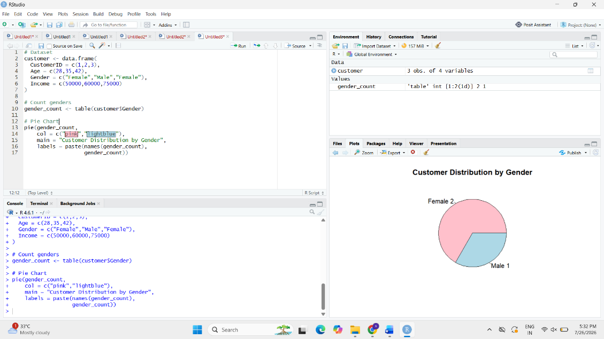

3.
# Dataset
customer <- data.frame(
CustomerID = c(1,2,3),
Age = c(28,35,42),
Gender = c("Female","Male","Female"),
Income = c(50000,60000,75000)
)

# Display Table
print(customer)

